Name: Herly Herdiansyah Saputra
NIM: 055716397
Permission to answer discussion 8

- Concept Map of Learning Materials

CONCEPT MAP / MIND MAP
MKWI4201 / MKDI4201 BAHASA INGGRIS

PART 1: BASIC COMMUNICATION (Sessions 1 - 3)
Modul 1: Formal & Informal Language (Slangs, Cliches, Colloquialism, Vocabulary, Sentences)
Modul 2: Office Environment & Descriptive Paragraph (Things in the Office, Adjectives, Prepositions of Place)
Modul 3: Informal Emails & Business Memos (Email Structures, Internal Communication vs External)

PART 2: WRITTEN BUSINESS COMMUNICATION (Sessions 4 - 6)
Modul 4: Business Letters & Formal Reports (Inquiries and Replies, Formal Report Structure)
Modul 5: Letters of Request, Appreciation, & Complaint Letters (Asking Politely, Thanking, Demanding Refunds/Exchanges)
Modul 6: Job Application (Cover Letters & CV) (Solicited vs Unsolicited, Application Letters, Curriculum Vitae)

PART 3: PROFESSIONAL SKILLS (Session 7)
Modul 7: Making Appointments & Giving Explanations (Arranging/Cancelling Meetings, Clarifying, Checking Understanding)
Modul 8: Presentation Skills (Structure: Opening, Body, Closing, Visual Aids Tips)
Modul 9: Negotiation Skills (Bargaining, Closing Deals, Handling Conflicts, Declining Offers)
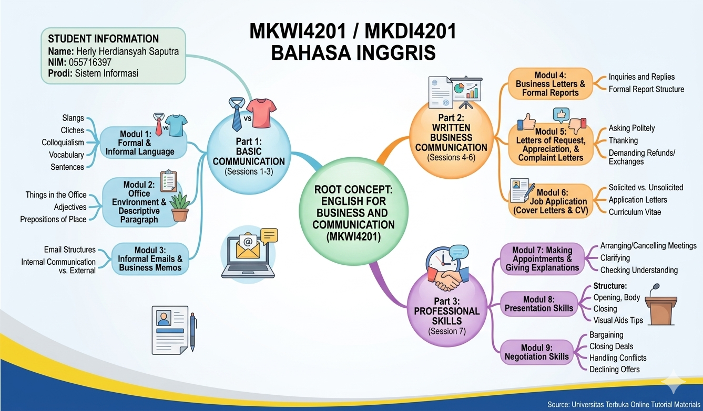

- Self-Reflection and Confidance Level
- Part that I am confident about:
Based on the tutorial sessions we have covered, I feel highly confident about the topics in Session 1 (Formal and Informal Language) and Session 2 (Things in the Office and Descriptive Paragraphs). Differentiating between formal and informal structures such as avoiding contractions, slangs, or clichés in professional business writing is very clear to me. I also find it pratical to describe an office workspace using proper adjectives and prepositions of place.

- Part that I am not confident about:
On the other hand, I feel less confident about Session 7 regarding Negotiation Skills (especially Handling Conflicts and Refusing Offers politely). It can be quite challenging to recall anf apply the specific formal phrases spontaneously when a deal cannot be easily reached or when we need to maintain a positive standing despite a disagreement.

- Question related to the learning materials:
I have a question regarding Session 7 (Negotiation): If we reach a complete deadlock or cannot settle our differeces in a business meeting, what is the most recommended closing phrese to end the session politely while still maintaining a good long term professional relationship with the client?

